Information and Application for

Couple Counseling

Your full legal name: Date:

Hello and thanks for contacting me. I know it might be challenging to take the first step to reach out for help so kudos to you for asking for support. Let’s discover if we are a good fit.

I have two specialties: working with high-achievers who are highly sensitive people and couples. My clients experience anxiety, stress, depression, grief, trauma, PTSD, and relationship problems.

INFORMATION ABOUT COUPLES COUNSELING

One of my teachers, Dr. Alexander Lowen, told me that it takes 30 years to make a good psychotherapist. You’ll be receiving four decades of my expertise.
There are several ways you can get to know my work so you can decide if you want to work with me.
- Read my websites and blog posts at Flourishing-Lives.com (for couples) and SensitiveIntrovert.com.

Watch the video: Four Horsemen: Don’t let them ruin your marriage. Benita A. Esposito 24 minutes.
- Read the webpage about Private Couples Retreats.
- Watch my book video. I talk about the gifts and challenges of being a highly sensitive introvert by sharing key moments of my life in a vulnerable way. 5 minutes.
- Read my book, or listen: The Gifted Highly Sensitive Introvert, Wisdom for Emotional Healing and Expressing Your Radiant Authentic Self. It’s a memoir and teaching stories to jump-start your learning and to help you determine if you would enjoy working with me.
- Listen to this meditation: A Journey Into Wholeness – A Guided Meditation MP3 Download. Or purchase a CD. Create a lifestyle with less stress and more inner peace. People benefit from daily downtime where our bodies experience a deep state of rest. After meditating, you’ll feel calmer and stronger. You won’t get so triggered when people do things you don’t like. Use this meditation to reduce anxiety and stress, depressed mood, fatigue, pain, insomnia, dis/ease, and irritability. It can also help you repair damaged relationships and increase your self-worth.

I only see clients on Zoom which is HIPAA compliant. You’ll need the following:
- a private setting so we can have a confidential session without background noise from people, pets, or devices.
- a stable internet connection.
- your smartphone, computer, or iPad.
Schedule: I see clients Monday-Thursday 10am-6pm Eastern on Zoom. The last appointment begins at 5pm. Private couples retreats are scheduled Friday-Sunday in-person or on Zoom.

For faster progress than 53-minute sessions:
- Schedule 80-minute appointments.
- Attend a private Couples Retreat.
- Attend an intensive group retreat.
Computer Skills: You’ll need to be able to read my Welcome Package forms in a WORD or a PDF document. You’ll need to print and sign forms, scan them, and return them via email. Or you can mail the forms via USPS.

Self-Pay Fees for Psychotherapy for 2026 | No Surprises Act Good Faith Estimate
Intake for individuals @ 53 minutes: $216.00 | Intake for couples @ 53 minutes: $257.50
Intake for individuals @ 80 minutes: $328.00 | Intake for couples @ 80 minutes: $390.00
Individual follow-up 53-minute sessions: $190.50 | Couples follow-up 53 minutes: $211.00
Individual follow-up 80-minute sessions: $290.50 | Couples follow-up 80 minutes: $321.00

Gottman Assessment: $115.00 (to be completed after the first session)
Insurance: I do not process insurance for couples counseling. Insurance is based on a medical model that requires a mental illness diagnosis. A couple cannot be assigned a diagnosis.
How to Make Payments: Please make your payment the morning of your session via Venmo. This is the only payment system that I use unless you live outside the USA, in which case I use PayPal. You may pay for multiple sessions at one time if you choose to. You may also mail a check.
Health Savings Accounts: Venmo might or might not process health savings account debit cards. You can mail me a check from your HSA account for multiple sessions. Some clients pay me and then get reimbursed by their health savings account. Talk to your employer to learn the rules that apply to you.
48-hour Cancelation Policy: If you can give me a week or more cancelation notice, it would be most appreciated. I want to fill your time slot if you cancel. Appointments broken within 48 hours must be paid in full before future sessions will be scheduled.
Newsletter: Would you like to receive my email newsletter? I send it at least once every 1 – 2 months. They contain educational articles about relationships, personal growth, holistic healing, and event notices.
__ Yes please, sign me up. __ No thanks.

APPLICATION for COUPLES COUNSELING

If you would like me to counsel you or participate in a couples retreat, please answer the following questions. I ask that each partner complete a separate document. Please use a Gmail address so our documents are encrypted and HIPAA compliant.

Note: This form does not constitute a professional relationship. We’re just getting to know each other. If I believe we are a good fit, I’ll invite you to a complimentary 10-minute Discovery Call and schedule an intake session.
Take the quiz to see if you score as a highly sensitive introvert. Email me your score, please.

What is your full address: street, city, state, country, and zip code?
What is your email address? If you have a Gmail address, please provide it so our correspondence will be encrypted and HIPAA-compliant.
What is your cell phone number?
What is your age? Date of birth? month/day/year:

How did you find me? If you did an internet search, what keywords did you use?
Please write a brief paragraph for each of the following:
- Describe the current challenges in your relationship.
- Describe your goals.
- What makes your relationship worth fighting for?
Do you experience now … or have you ever experienced … any of the following:
- Severe depression, suicidal thoughts, or suicidal attempts?
- Have you experienced physical, sexual, or emotional abuse or other forms of trauma?
- Do you drink to excess, use drugs without a prescription, or use recreational drugs?
- Do you experience any other addictions, an eating disorder, or bipolar symptoms?
- Have you ever attended an in-patient treatment center for emotional or substance abuse issues?
- Have you ever had a psychiatric diagnosis? If so, what?
- Have you ever had legal trouble other than parking tickets? Possible upcoming court cases?

I do not work with clients with the following: severe depression, suicidal ideation, homicidal ideation, domestic violence, addiction, eating disorders, schizophrenia, bipolar disorder, or borderline personality disorder. If any of these are discovered, I’ll make a referral to an appropriate practitioner.

If you think we might be a good fit …

- Please email your answers to Benita@EspositoInstitute.com.
- I will reply within 48 hours Monday-Thursday. If you don’t hear from me, please contact me again by email or phone. There might be a technical glitch.
- I offer a complimentary 10-minute Discovery Call Monday-Thursday. If you want to proceed, please email me with three days and times you can talk on the phone, or if you would like, we can meet on Zoom.

I look forward to hearing from you soon.
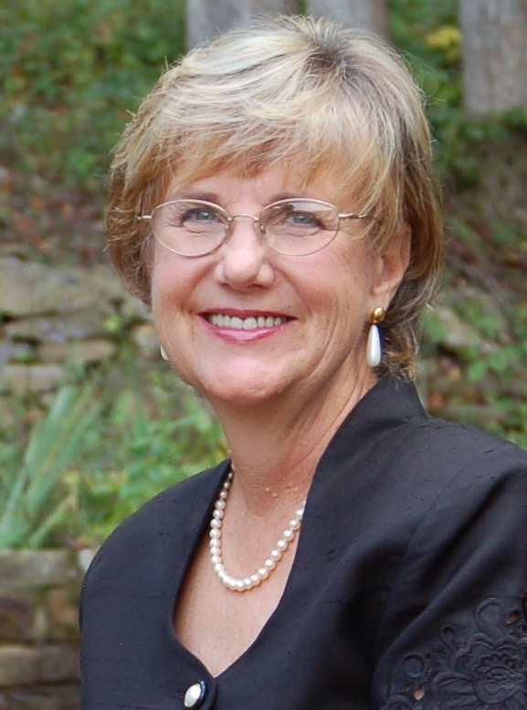
Bright Blessings,

Benita A. Esposito, MA, LPC, LCMHC

Email: Benita@EspositoInstitute.com

Psychotherapy for GA and NC residents
www.Flourishing-Lives.com

Life Coaching and Spiritual Counseling globally
www.SensitiveIntrovert.com

Cell: 770 998 6642

Mail: PO Box 1074, Young Harris, GA 30582

